**Bahria University, Lahore Campus**

Department of Computer Sciences

Lab Journal 02

**(Fall 2023)**

|  |  |  |
| --- | --- | --- |
| Course: | **Digital Communication Network Lab** | Date: 28-09-2023 |
| Course Code: | CSL-320 | Max Marks: 20 |
| Faculty’s Name: | Dawood Akram | Lab Engineer: Muhammad Umar Nasir |

Name: AFFAN AHMAD ___ Enroll No: _03-134221-003___

**Objective(s):**

To be familiar with network terminologies. Compare network information to other PCs on the network. Learn to use TCP/IP Groper (ping) command from a workstation.

## Tool(s) used:

Command Line Interface (CLI)

## Task 01 TCP/IP CONFIGRATION

**Step 1:** Connect into the Internet

Establish and verify connectivity to the Internet. This ensures the computer has an IP address.

**Step 2:** Gather TCP/IP configuration information

Use the Start menu to open the Command Prompt, an MS-DOS-like window. Press **Start** >

**Programs** > **Accessories** > **Command Prompt** OR **Start** > **Programs** > **Command Prompt** OR **Press Start>Run Then type cmd.**

The following figure shows the Command screen. Type **ipconfig** and press the **Enter** key. The spelling of **ipconfig** is critical while case is not. It is short for IP Configuration.

**Fig 2.1 ipconfig on Command Prompt**

This first screen shows the IP address, subnet mask, and default gateway. The IP address and the default gateway should be in the same network or subnet, otherwise this host would not be able to communicate outside the network. In the figure the subnet mask tells us that the first three octets must be the same to be in the same network.

**Note:** If this computer is on a LAN, the default gateway might not be seen if it is running behind a Proxy Server Record the following information for this computer.

**Step 3:** Record the following TCP/IP information for this computer

**IP address:** ____172.23.18.218__

**Subnet Mask:** _______________255.255.255.0____

**Default Gateway:** _____________172.23.18.1_____________

**Step 4:** Compare the TCP/IP configuration of this computer to others on the LAN

If this computer is on a LAN, compare the information of several machines.

**Are there any similarities?**

No

**What is similar about the IP addresses?**

In Ip address 172.23.18 are similar with default gateway

**What is similar about the default gateways?**

In DEFAUT GATEWAY 172.23.18 are similar with IP ADDRESS

The IP addresses should share the same network portion. All machines in the LAN should share the same default gateway.

**Write a couple of the IP Addresses**

**172.21.160.1**

**Step 5:** Check additional TCP/IP configuration information

To see detailed information, type **ipconfig /all** and press **Enter**. The figure shows the detailed IP configuration screen.

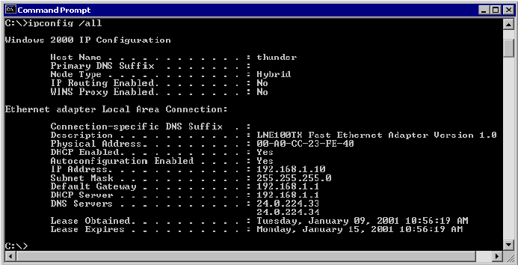

**Fig 2.2 ipconfig/all on Command Prompt**

The host name should be displayed. Also, the DHCP server address, if used, and the date the IP lease starts and ends should be displayed. Look over the information. Entries for the DNS, used in name resolution servers, may also be present.

The previous figure reveals that the router is performing both DHCP and DNS services for this network. This would likely be a small office or home office (SOHO) or small branch office implementation.

**Notice the Physical Address (MAC) and the NIC model (Description).**

**In the LAN, what similarities about the Physical (MAC) Addresses are seen?**

Adapter Ethernet and adapter vEthernet have different physical mac addresses.

While not a requirement, most LAN administrators try to standardize components like NICs. Therefore, it would not be surprising to find all machines share the first three Hex pairs in the adapter address. These three pairs identify the manufacturer of the adapter.

**Write down the IP addresses of any servers listed.**

**172.23.18.218**

**Write down the computer Host Name.**

**BULC-NLAB-218**

**Write down the Host Names of a couple other computers.**

**BULC-NLAB-218**

**Step 6:** Close the screen

Close the screen when finished examining network settings.

Repeat the previous steps as necessary. Make sure that it is possible to return to and interpret this screen.

**Task 02 Using “ping” and “tracert” Commands**

**Step 1:** Establish and verify connectivity to the Internet

This ensures the computer has an IP address.

**Step 2:** Access the command prompt

**Step 3:** Ping the IP address of another computer

In the window, type **ping**, a space, and the IP address of a computer recorded in the previously. The following figure shows the successful results of **ping** to this IP address.

**Fig 2.3 ping by ip adress on Command Prompt**

**ping** uses the ICMP echo reply feature to test physical connectivity. Since **ping** reports on four attempts, it gives an indication of the reliability of the connection. Look over the results and verify that the **ping** was successful. Is the **ping** successful?

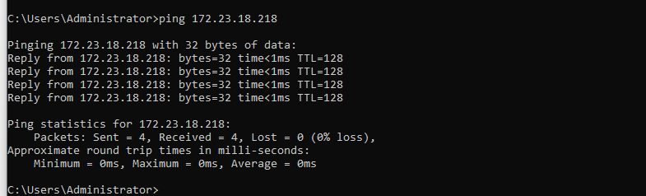

**Step 4:** Ping the IP address of the default gateway

Try to **ping** the IP address of the default gateway if one was listed in the last exercise. If the **ping** is successful, it means there is physical connectivity to the router on the local network and probably the rest of the world.

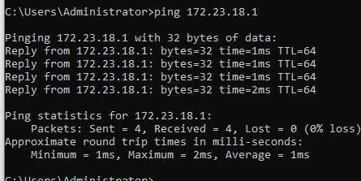

**Step 5:** Ping the IP address of a DHCP or DNS servers

Try to **ping** the IP address of any DHCP and/or DNS servers.

Was the **ping** successful?

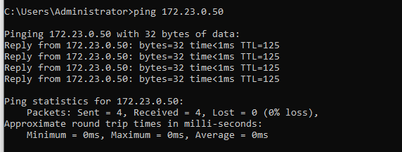

**Step 6:** Ping the Loopback IP address of this computer

Type the following command**: ping 127.0.0.1**

The 127.0.0.0 network is reserved for loopback testing. If the **ping** is successful, then TCP/IP is properly installed and functioning on this computer.

Was the **ping** successful?

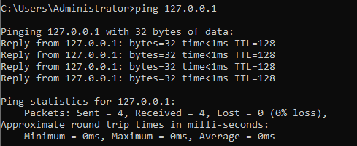

**Step 7:** Ping the hostname of another computer

Try to **ping** the hostname of the computer that was recorded in the previous lab. The figure shows the successful result of the **ping** the hostname.

**Fig 2.4 ping by host name on Command Prompt**

Look over the results. Notice that the first line of output shows the host name, m450 in the example, followed by the IP address. This means the computer was able to resolve the host name to an IP address. Without name resolution, the **ping** would have failed because TCP/IP only understands valid IP addresses, not names.

If the **ping** was successful, it means that connectivity and discovery of IP addresses can be done with only a hostname. In fact, this is how many early networks communicated. If successful, then **ping** a hostname also shows that there is probably a WINS server working on the network.

**Note:** It would not be uncommon for a Windows 2000 or XP networks to not support this feature. It is an old technology and often unnecessary.

If the last **ping** worked, try to **ping** the hostname of any another computer on the local network. The following figure shows the possible results.

**Note:** The name had to be typed in quotes because the command language did not like the space in the name.

**Fig 2.5 ping by host name with spacing on Command Prompt**

**Step 8:** Ping the Cisco web site

Type the following command: **ping www.cisco.com**

**Fig 2.6 ping by web address on Command Prompt**

The first output line shows the Fully Qualified Domain Name (FQDN) followed by the IP address. A Domain Name Service (DNS) server somewhere in the network was able to resolve the name to an IP address. DNS servers resolve domain names, not hostnames, to IP addresses.

Without this name resolution, the **ping** would have failed because TCP/IP only understands valid IP addresses. It would not be possible to use the web browser without this name resolution.

With DNS, connectivity to computers on the Internet can be verified using a familiar web address, or domain name, without having to know the actual IP address. If the nearest DNS server does not know the IP address, the server asks a DNS server higher in the Internet structure.

**Step 9:** Ping the Microsoft web site

Type the following command: **ping www.microsoft.com**

**Fig 2.7 ping failure for Microsoft because some Microsoft routers are configured to ignore ping**

Notice that the DNS server was able to resolve the name to an IP address, but there is no response. Some Microsoft routers are configured to ignore **ping** requests. This is a frequently implemented security measure.

**ping** some other domain names and record the results. For example, **ping www.msn.de**

**Step 10:** Trace the route to the Cisco web site

Type **tracert www.cisco.com** and press **Enter**.

**Fig 2.8 tracert website on Command Prompt**

**tracert** is TCP/IP abbreviation for trace route. The preceding figure shows the successful result when running **tracert** from Bavaria in Germany. The first output line shows the FQDN followed by the IP address. Therefore, a DNS server was able to resolve the name to an IP address. Then there are listings of all routers the **tracert** requests had to pass through to get to the destination.

**tracert** uses the same echo requests and replies as the **ping** command but in a slightly different way. Observe that **tracert** actually contacted each router three times. Compare the results to determine the consistency of the route. Notice in the above example that there were relatively long delays after router 11 and 13, possibly due to congestion. The main thing is that there seems to be relatively consistent connectivity.

Each router represents a point where one network connects to another network and the packet was forwarded through.

**Step 11:** Trace other IP addresses or domain names

Try **tracert** on other domain names or IP addresses and record the results. An example is **tracert** [**www.hec.gov.pk**](http://www.hec.gov.pk)

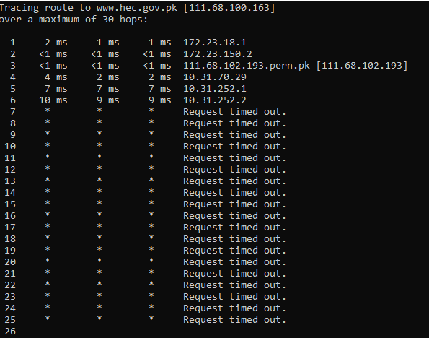

**Step 12:** Trace a local host name or IP address

Try using the **tracert** command with a local host name or IP address. It should not take long because the trace does not pass through any routers.

**Fig 2.9 tracert a nearby Router**

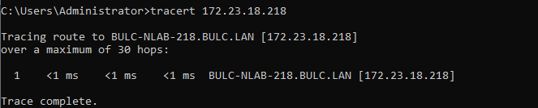

**Task 03 Create a Peer to Peer Connection using RJ45**

**Step 1:** Physical connection between two computers

Connect the RJ45 cable to the LAN network card at the back of the PC

**Step 2:** Computer setup for peer to peer connection

1. To create a peer-to-peer network start Windows Explorer. Depending on the computer or its manufacturer, in the left frame, you may see an icon labeled Homegroup:

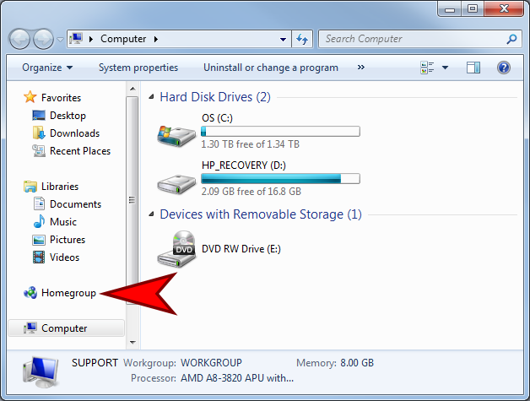

1. Click on “homegroup”.
2. A new window comes up

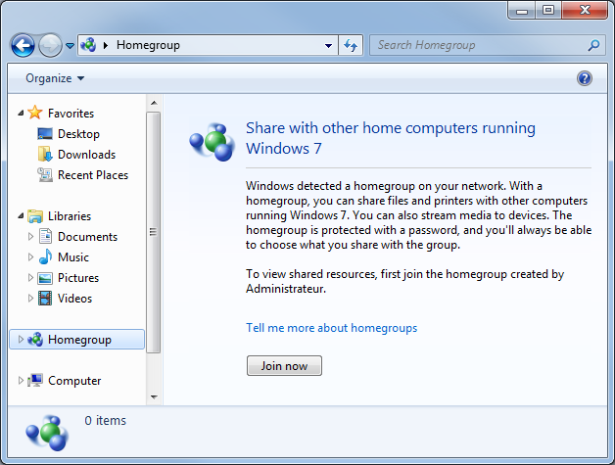

Click on join now.

1. Another window shows up: click next

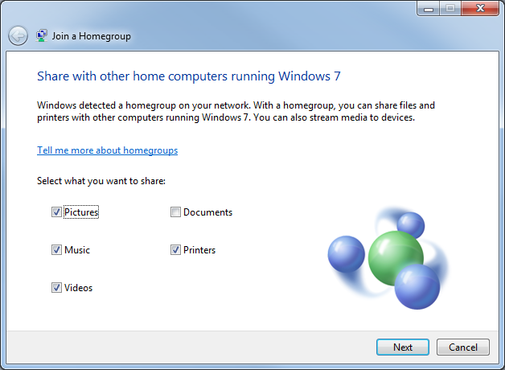

**Task 04 Sharing a Folder**

**Step 1:** To create a folder.

1. Open Windows Explorer or any file utility of your choice. select the drive. Right-click it or right-click the right frame, position the mouse on New, and click Folder:

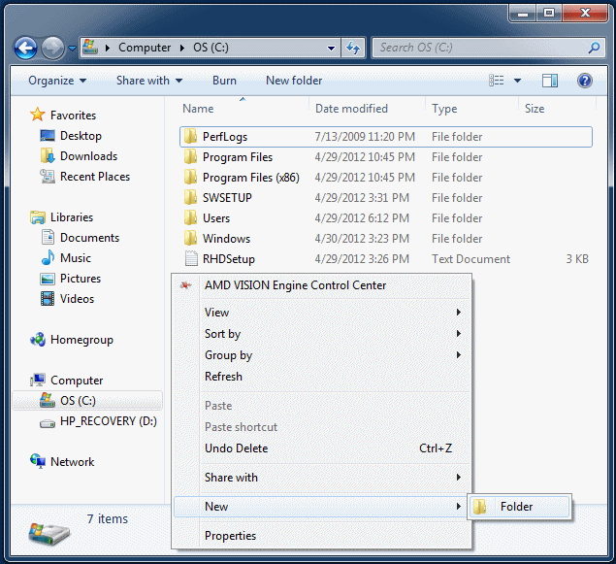

Give a name to the folder and press Enter

**Step 2:** To share it

1. Start Windows Explorer and display the drive where the folder is located
2. Right-click the folder -> Share With -> Specific Profile

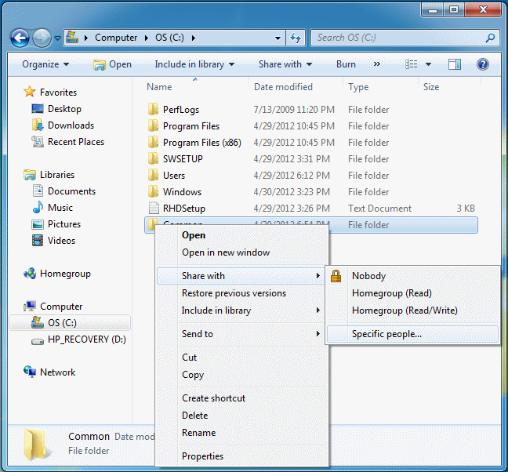

1. Click the arrow of the combo box:

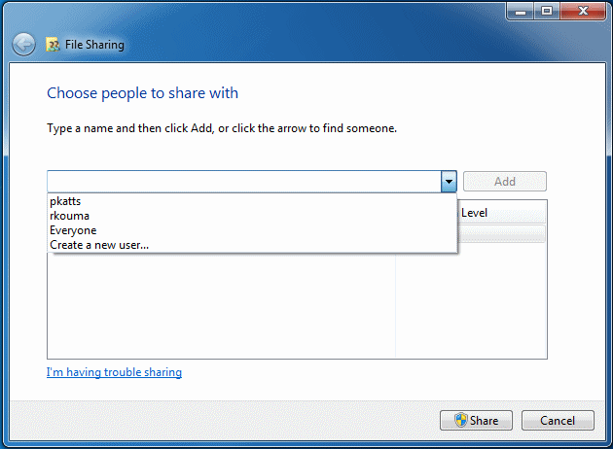

1. Then:
   1. If you want to [control access](http://www.functionx.com/networking/Lesson04.htm) of the folder for all user accounts, click Everyone
   2. If you want to control access for a specific account and that account is in the list, select it

If you want to control access for a certain user but his or her account is not listed, click Create A New User... and create the new account.

Under Permission Level click the down-pointing arrow for the account you selected.

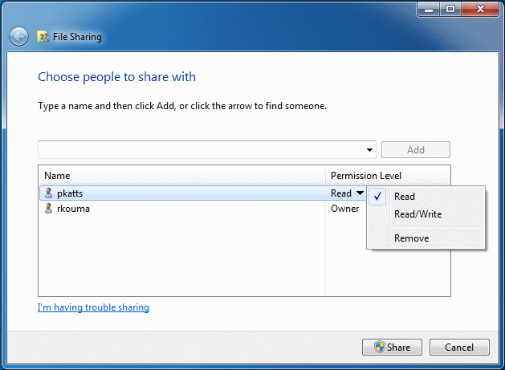

Select the desired permission

Click Share

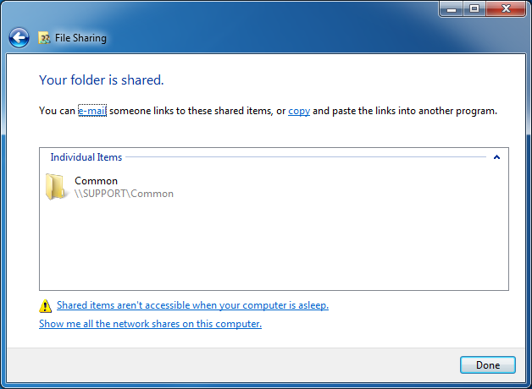

Click Done.

**Step 3:** Accessing shared folder

When a folder is shared in a computer, the other computers can access it. To access such a folder from another computer, you must use an account that exists in the computer where the folder is shared.

To access a shared folder:

1. Open Windows Explorer
2. In the left frame, click Network.  
   The right should play the names of the computers of the same network
3. Double-click the icon of the computer where the desired folder is located
4. A Windows Security dialog box may come. In the top text box, type the name of the computer that has the folder, followed by \, followed by the user account you created in that computer
5. Press Tab
6. Type the password that was given to that account

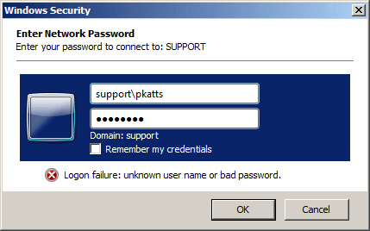

About the check box:

* + If you leave Remember My Credentials unchecked, the next time you try accessing the folders of that computer, you will be asked to provide the credentials (user name and password) again
  + If you check Remember My Credentials, next time, you can access the folders of that computer

When you are ready, click OK  
The computer should then show its shared folder(s).

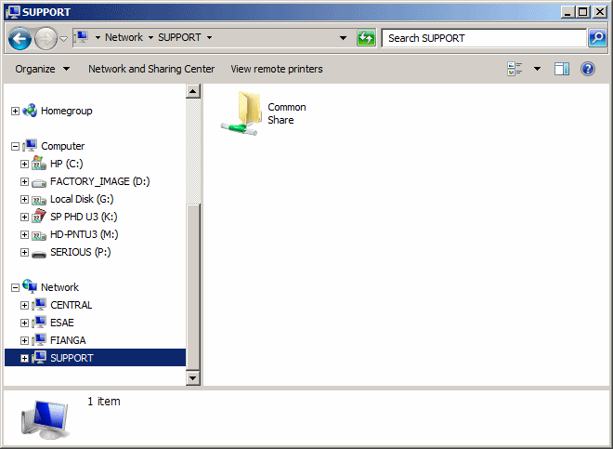

You can then:

* + Double-click the folder to see its contents
  + Open a file that is in that folder
  + Create a file and save it in that folder
  + Copy files and put them in that folder
  + Put various types of files (pictures, music, videos, presentation, etc) in that folder

